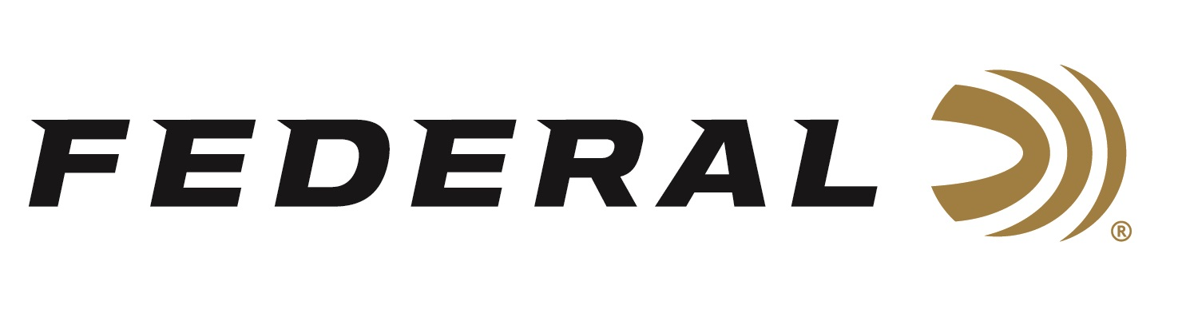

FOR IMMEDIATE RELEASE

Team Federal Captures Three Gold Medals at ISSF World Cup

ANOKA, Minnesota – May 3, 2022 – Team Federal continued its astonishing performance on the world stage by capturing three gold medals and a silver at the Lonato World Cup in Lonato, Italy. The competition, considered the deepest and toughest from a talent perspective of the World Cup events, was held April 19-30, 2022. USA led the gold medal count and Team Federal’s Caitlin Connor had a part in all three of the gold medal performances.

Caitlin Connor, who started shooting at the age of 15 in the 4-H program, claimed gold in Women’s Skeet, Women’s Team Skeet, and paired with Team Federal’s Vincent Hancock to win the Mixed Team Skeet. Connor defeated a competitor from Great Britain in the Women’s Skeet finals, marking her first ever individual title at a World Cup event. Connor than teamed up with Team Federal’s and Olympic Gold Medalist Amber English and Dania Vizzi to win the Women’s Skeet Team gold medal.

Interviewed by USA Shooting, Connor credited her team members with the success. “I would not have been able to get those golds if it weren’t for my teammates,” said Connor. “We have a really strong team, and it was awesome to be part of it,” said the Winnfield, Louisiana native.

Three-time Olympic Champion Vincent Hancock captured a silver medal in the Men’s Skeet competition and paired with Caitlin Connor to win the Mixed Team Skeet. It was the first time the two had teamed together to compete in a World Cup event.

Federal Ammunition can be found at dealers nationwide or purchased online direct from Federal. For more information on all products from Federal or to shop online, visit www.federalpremium.com.

Press Release Contact: JJ Reich
Senior Manager – Press Relations
E-mail: VistaPressroom@VistaOutdoor.com

About Federal Ammunition
Federal, headquartered in Anoka, MN, is a brand of Vista Outdoor Inc., an outdoor sports and recreation company. From humble beginnings nestled among the lakes and woods of Minnesota, Federal Ammunition has evolved into one of the world's largest producers of sporting ammunition. Beginning in 1922, founding president, Charles L. Horn, paved the way for our success. Today, Federal carries on Horn's vision for quality products and service with the next generation of outdoorsmen and women. We maintain our position as experts in the science of ammunition production. Every day we manufacture products to enhance our customers' shooting experience while partnering with the conservation organizations that protect and support our outdoor heritage. We offer thousands of options in our Federal Premium and Federal® lines-it's what makes us the most complete ammunition company in the business and provides our customers with a choice no matter their pursuit.

